MEXICAN LAELIAS
- What are the plant and flower characteristics of true Laelia species?

- List 3 key Laelia species, with the type and number of awards to date

- Name 3 popular primary hybrids of at least one of the species.

- For today’s awards, how many flowers (per inflorescence) would you expect when judging Laelia anceps?

- Name 4 of the different color forms of Laelia anceps

- The below hybrid Lc. Hsin Buu Lady ‘YT’ received an 88pt AM/AOS. What is the hybrid cross? Based on type and breeding, why do you think the judging team gave it such a high point score?

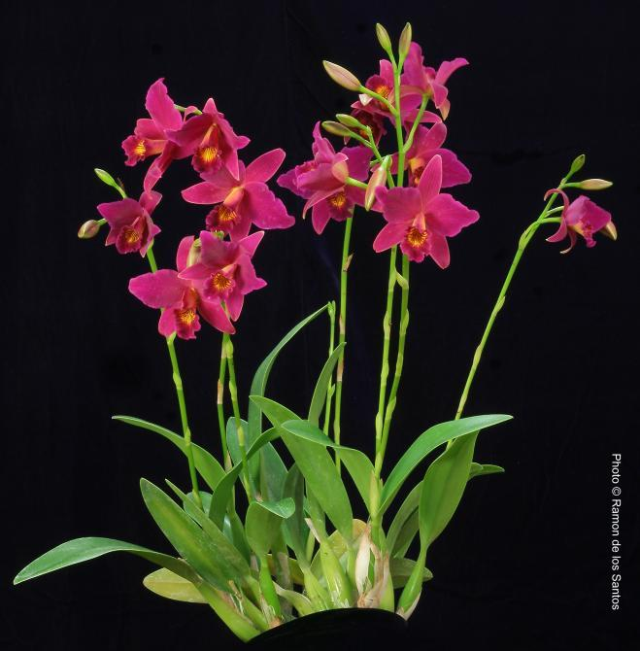
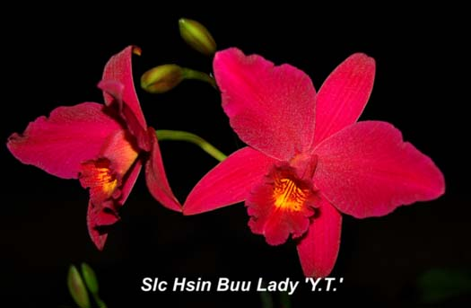

- If the below Laelia anceps var. veitchiana came to your table, would you award it (assume it had 3 flowers with natural spread of 11 cm)? Why or why not? If yes, how many points would you give it?

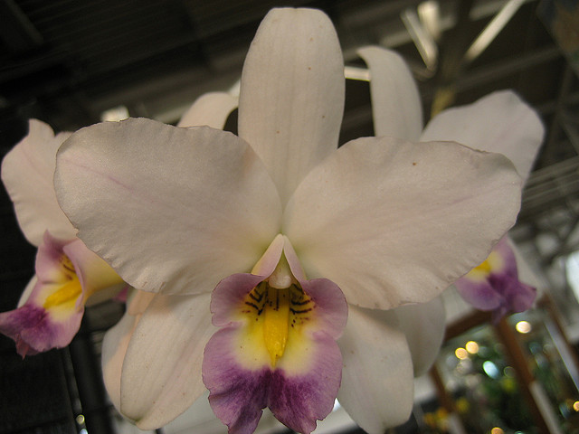

- Please provide an award description of the below Lc. Miss Wonderful, assume characteristics not seen:
