BIFOLIATE CATTLEYAS

- What are the plant and flower characteristics of bifoliate Cattleya species?

- Do you use the Cattleya or General scale when scoring bifoliate Cattleyas? Explain your reasoning.

- List 3 key bifoliate Cattley species, with the type and number of awards to date

- Are there any dwarf bifoliate Cattleya species? Name 2 popular primary hybrids of at least one of the species.

- How many flowers would you expect on C. tigrina? How about C. granulosa? Are there any bifoliate species where 2 flowers might be acceptable in judging?

- When judging bifoliate Cattleya species and hybrids, what would you expect in terms of color, form, arrangement, and number of flowers?

- Although arrangement of flowers is only 10 points, would you weight more heavily on arrangement in bifoliate Cattleya species and their hybrids? Why or why not?

- If the below C. intermedia v. orlata came to your table, would you award it (assume it had natural spread of 7.5 cm)? State your reasons.

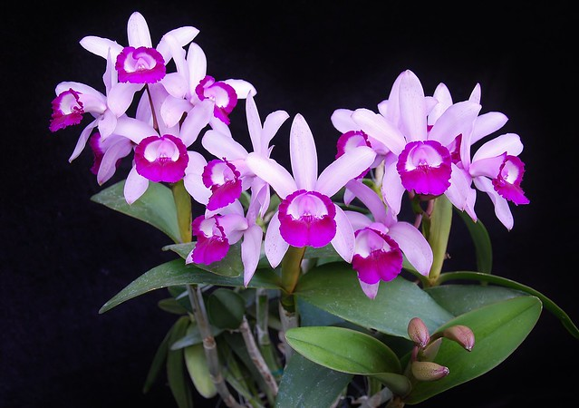

- Please provide an award description of the below C. amethystoglossa:
- 