Terrestrial Orchids
- What is the name of this popular species? List the number by type of awards. Based on recent awards, how many flowers would you expect per inflorescence? Since the flowers are very similar within the species, what characteristics would you consider in awarding the plant?
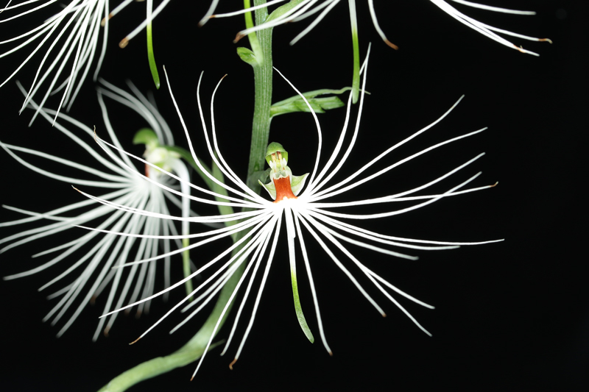

- What are the different color forms of Habenaria rhodocheila?

- List the number/type of awards for the species in genus Pecteilis

- List the number/type of awards for the most awarded Pleione species. How many flowers would you expect per inflorescence for this genus?

- Although all the jewel orchids do flower, they are primarily grown for their distinctly veined and colorful leaves. A beautifully grown Dossinia marmorata comes to your table with over 20 pristine growths, but no flowers. Are you able to judge this plant? Can you give it a cultural award?

- How many flowers would you expect for a Pterostylis curta to receive a cultural award?

- Write a description for this Habenaria. Assume characteristics not seen

